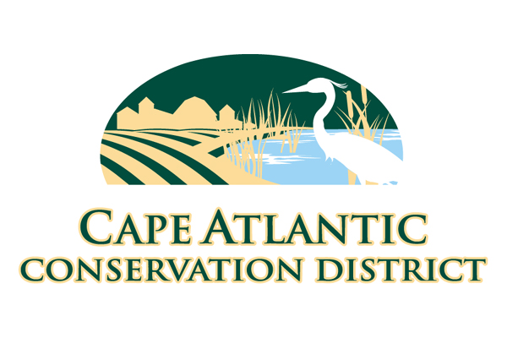
6260 Old Harding Highway
Mays Landing, New Jersey 08330
Phone (609) 625-3144 Fax (609) 625-7360
www.capeatlantic.org

AGENDA
January 16, 2025

- Chairman, Meeting called to order and Public Notice Announcement
In review of the Sunshine Law, Chapter 231 PL 1975 adequate notice of this meeting has been provided by mail to The Press of Atlantic City and Gazettes of Atlantic and Cape May Counties specifying time and place this meeting is to be held.

- Flag Salute

- Roll Call and Determination of Quorum

IV. Minutes
- Minutes of December 17, 2024, 2024 Meeting
- Executive Session Minutes of December 17, 2024 Meeting
- Special Open Public Meeting Minutes of December 17, 2024

V. Finances:
A. Treasurer’s Reports
  - District Financials – December 2024
  - Plant Materials Center Financials – December 2024

VI. New Business:
A. Board Reorganization
B. Soil Erosion and Sediment Control Plans
1. Certifications – December 2024
2. Re-Certification – December 2024
3. 251 Updates

C. Farmland Program - NONE
D. NRCS Civil Rights Review
E. 251 Access Data-base

VII. Correspondance:
NONE

VIII. Old Business:
A. Education
B. Grants
C. Meetings
D. Forestry Update
E. Agriculture Update
F. Coastal Zone Soil Survey
G. District Employee Handbook
H. Merger

IX. Comments:
- Staff
- Supervisors
- NRCS
- SSCC
- Rutgers
- Public

X. Executive Session: (if necessary)
A. Personnel

XI. Action items from Executive Session (if any)

XII. Next Meeting – Thursday February 20, 2025, at 8:00 a.m.
District Office, Mays Landing, NJ

XIII. Adjournment

